USER GUIDE

# INTRODUCTION

I’ve created a windows store app on News Stand. Where user can know news all over the world. He can run with time, what’s going around world and him. I’ve made many sections about news, I included global news, national news, sports news, weather forecast, health news, education news, entertainment news, science news & some facts about Pakistan. I’ve used RSS feeds for news. I used app bar for navigation, search pane for search different pages.

index

1. News Stand
2. Global News
3. National News
4. Sports News
5. Weather News
6. Health News
7. Education News
8. Entertainment News
9. Facts
10. App Bar
11. Search Pane

news stand

It is main page where you can go to any page of news.



global news

In global news you can know news of all over the world and news of different fields.



national news

In national news you can know news of different countries and different cities of Pakistan.



Sports news

In this section all type of sports news are available.



WeaTHER news

In this you just need to enter your country name, after enter it you can see cities of that country in combo box, click on any one will show temperature of that city.

Health News

In this you can know health news from two sources BBC & the New York Times.



Education News

On the click on education pic you will go to news of it.



Entertainment News

In this section you can know news of Hollywood, Bollywood & fashion.



FACTS

You can know some facts about Pakistan.

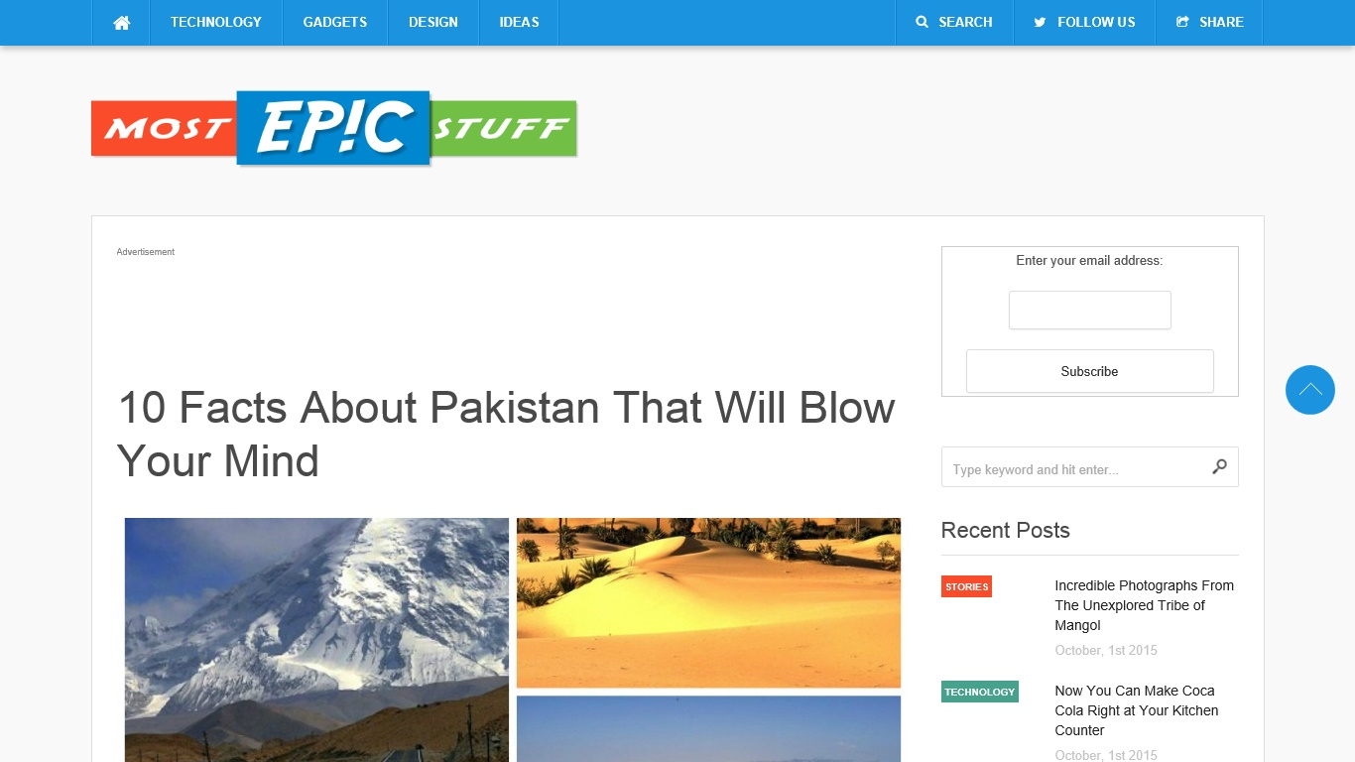

APP BAR

You can navigate from one page to other and can terminate app via app bar. Just need to right click on page or web view in some pages.

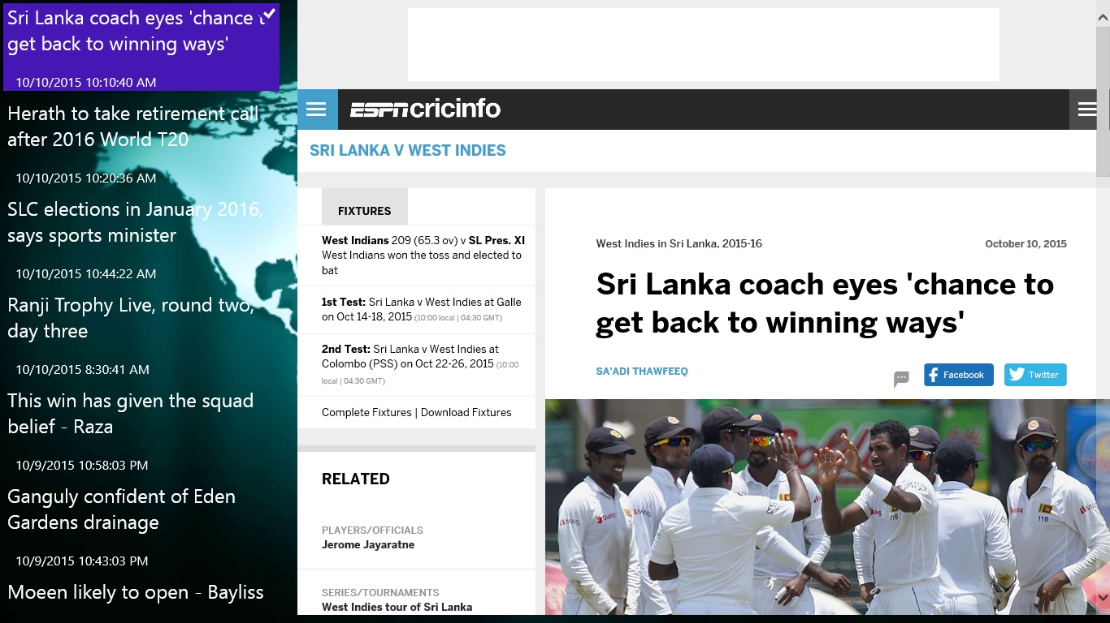

rss PAge

When you click on any news its news will appear on RSS page. When you click on it then news will appear on right side.



SEARCH PANE

You can search different pages via search pan. Just right click on page. It help in easy navigation.

Sources

* CNN
* BBC
* ESPN
* THE NEW YORK TIMES
* THE NEWS
* BOLLYWOOD HUNGAMA
* GURDIANS
* TIMES OF INDIA
* ARAB NEWS
* GULF NEWS.COM
* GLAMOUR.COM
* FASHION TRENDS.COM
* CINEMABLEND.COM
* http://www.ei-ie.org/rss